SPEAK-n-PAY
(VOICE-BASED PAYMENT ENTRY SYSTEM)

Screen 1: Dashboard
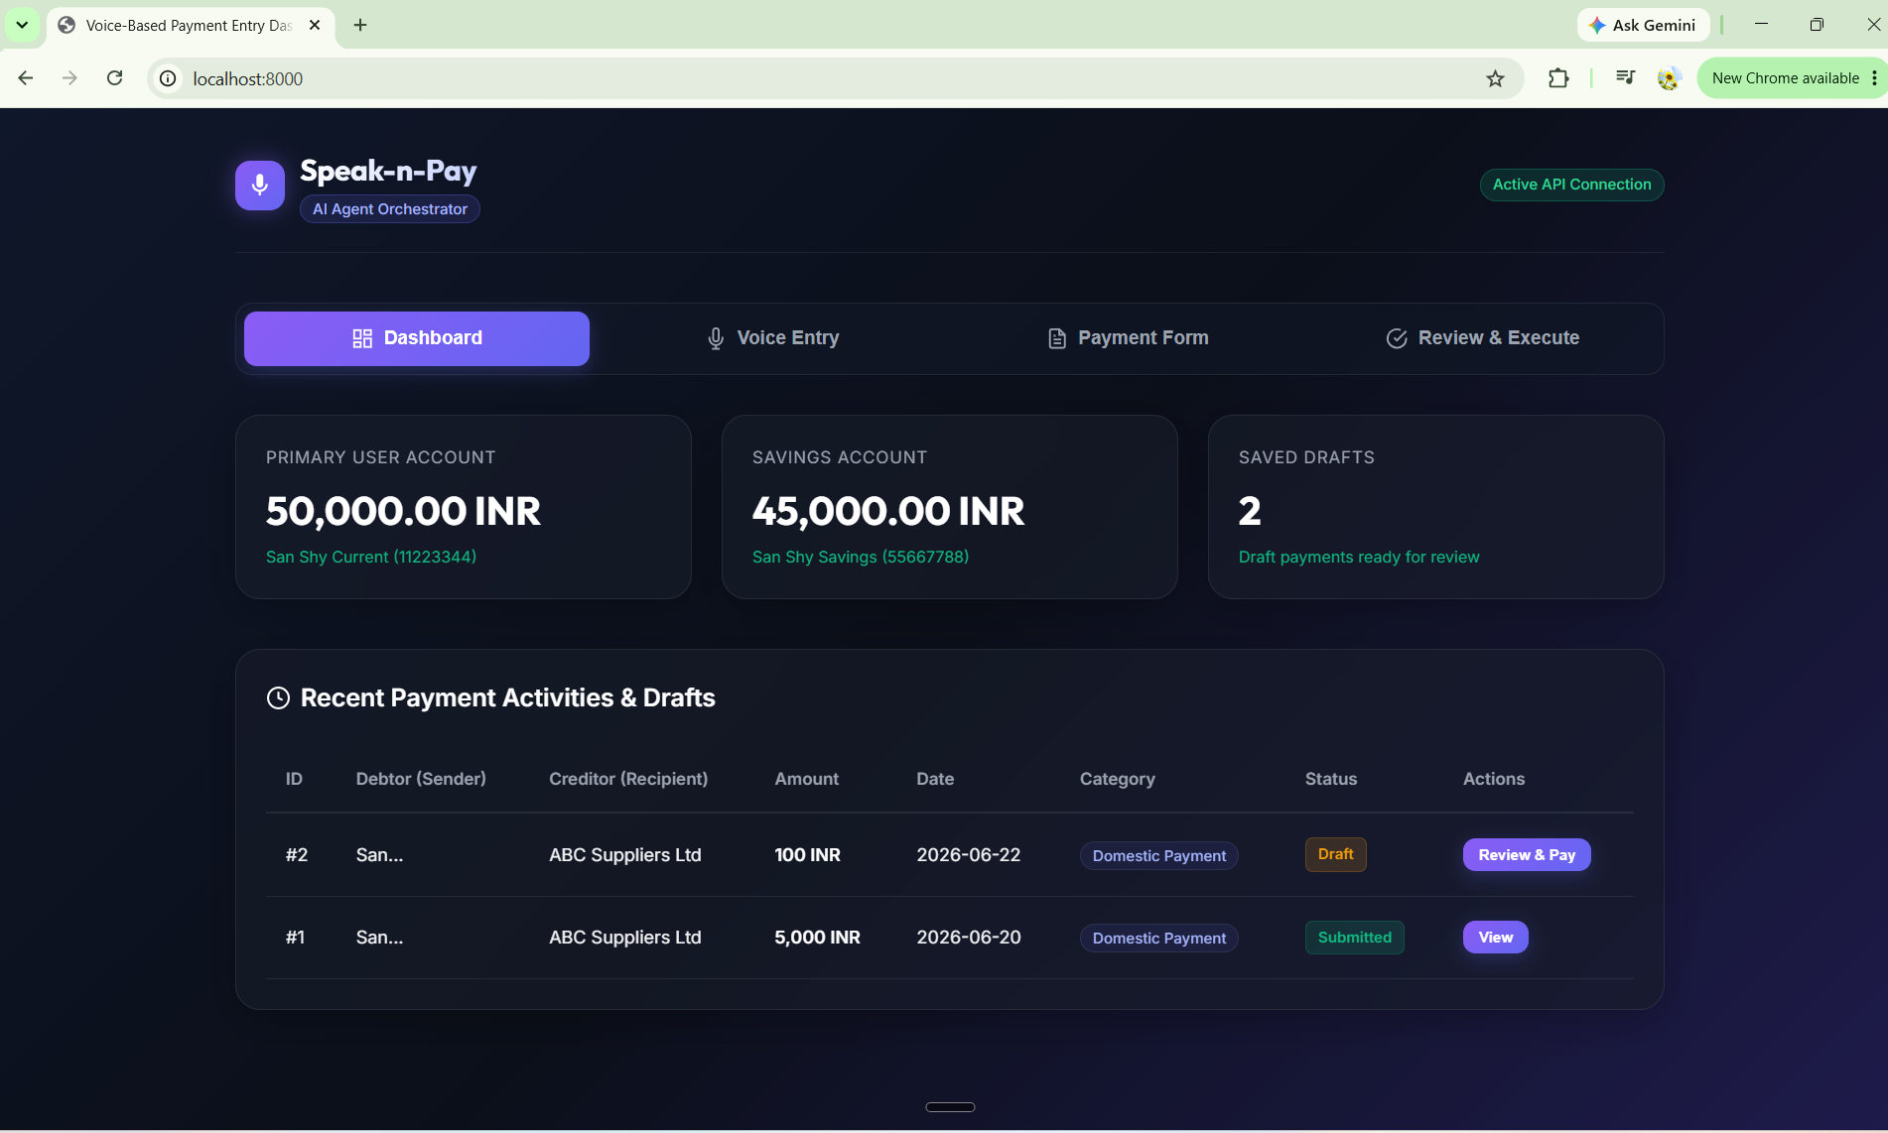
Screen 2: Voice Entry (a)
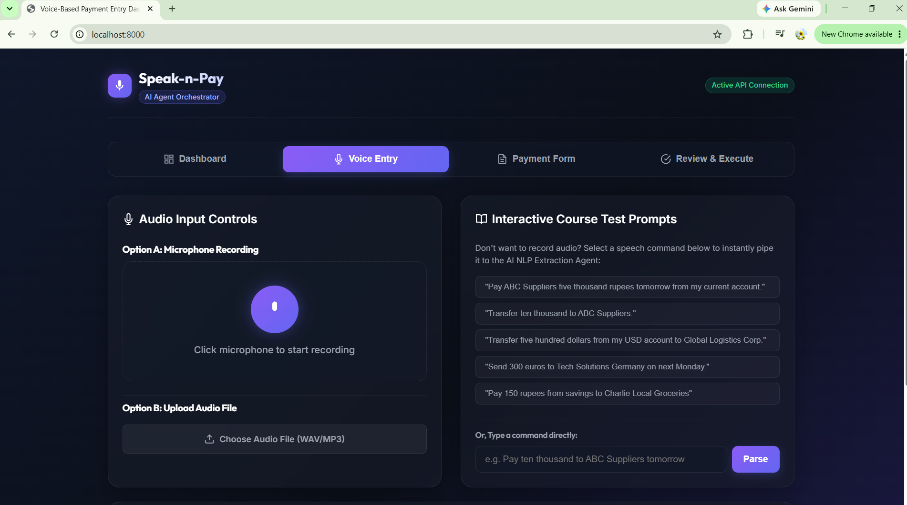

Screen 2: Voice Entry (b)
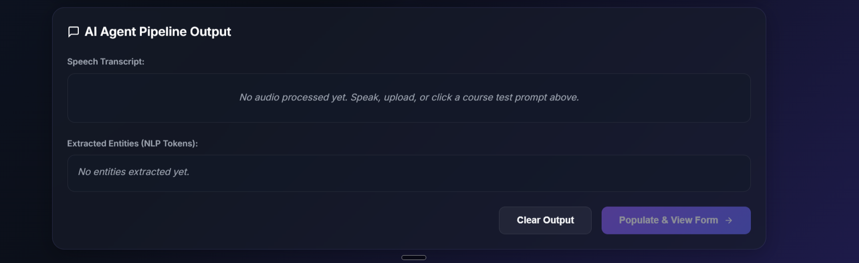
Screen 3: Payment form
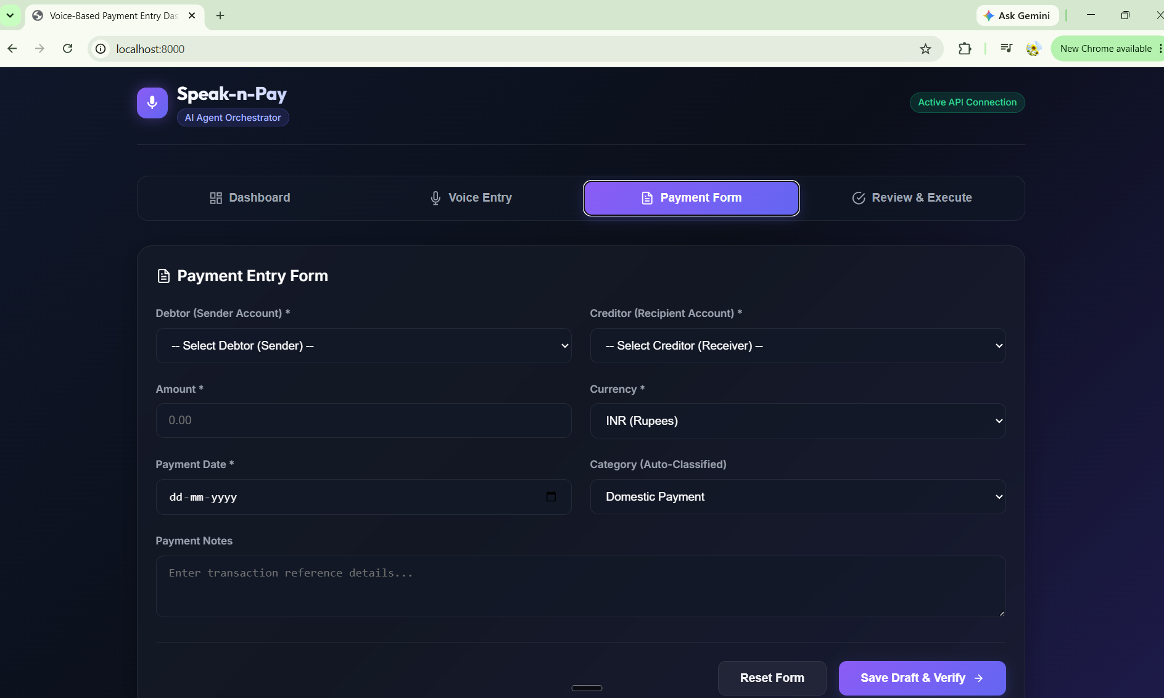
Screen 4: Review & Execute
